RESOLUTION NO.__________

RE: CERTIFICATE OF APPROPRIATENESS UNDER THE
PROVISIONS OF THE ACT OF THE PENNSYLVANIA
LEGISLATURE 1961, JUNE 13, P.L. 282 (53
SECTION 8004) AND BETHLEHEM ORDINANCE NO.
3952 AS AMENDED.

WHEREAS, it is proposed to install a new sign at 711 E 4th St.

NOW, THEREFORE, BE IT RESOLVED by the Council of the City of Bethlehem that a Certificate of Appropriateness is hereby granted for the work.

Sponsored by: (s)

(s)

ADOPTED BY COUNCIL THIS DAY OF

(s)
President of Council

ATTEST:

(s)
City Clerk

HISTORIC CONSERVATION COMMISSION

CASE # 614– It is proposed to install a new sign at 711 E 4th St.
OWNER/APPLICANT: Louis Calixto/ Keenya Mathis

The Commission upon motion by Mr. Roeder seconded by Mr. Evans adopted the proposal that City Council issue a Certificate of Appropriateness for the proposed work described herein:
- The proposal to install a new sign at 711 E 4th St. was represented by Keenya Mathis.

- The sign will read “KeKe’s Beauty Supply” in red lettering on a white background with a woman’s profile logo as depicted in rendering submitted.

- The sign will ideally be placed on the center glass panels of each storefront window on either side of the entrance after the removal of the security bars.

- If the landlord is not willing to remove the security bars and existing box sign above the entrance, the sign may be installed in the box sign.

  - The new sign will be located in the center of the 2’ x 10’ box sign on a white background.

  - The box sign will not be internally illuminated.

- The motion to approve the proposal was unanimously approved.

CU: cu
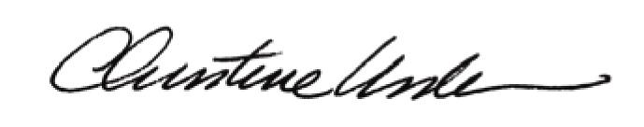

By:

Date of Meeting: April 17, 2017 Title: Historic Officer

